Spatio-temporal variation of fecundity among primiparous and multiparous snow crab and rates of egg loss, in the southern Gulf of St. Lawrence
Abstract
- Large dataset shows two distinct clusters of fecundity, which are associated with consistent differences between primiparous and multiparous fecundity levels.
- Primiparous females are 30-33% less fecund than full-clutched multiparous females.
- This difference is consistent with a 12% pubescent moult growth rate.
- Primiparous females show little evidence of egg loss.
- Multiparous females show a well-defined maximum fecundity, along with significant levels of egg loss.
- Comparison of datasets from different years and areas show little evidence of difference from the patterns observed in the aggregated data.

- Fecundity observations were analyzed using a new fecundity model which accounts for uncertainties in the data: identification of maturity stage, reductions in egg size as a function of carapace condition, and data outliers.
- The large number of fecundity samples allows us both to more clearly perceive general patterns in the data, and the hierarchical structure of the model aids in determining spatio-temporal variations among our samples.
- Our results indicate that variations in the demographic composition of mature females can largely account for most of the variation in fecundity models from around the world, if not properly accounted for.

Introduction:
Snow crab fishery, population life cycle overview:
- Importance of snow crab fishery.
- Widespread distribution of snow crab.
- Snow crab life cycle.
- Females are not exploited.
Female reproductive biology and known fecundity drivers:
- Female reproductive biology summary.
- Discuss main factors which affect crab fecundity (causal diagram?):
  - Oocyte production.
    - Crab health (energy reserves, food availability, environmental conditions).
    - Crab size.
  - Egg loss during incubation.
    - Fertilization.
    - Mortality (predation, parasites, disease, development issues).
    - Mechanical (attachment to pleopods, injury, interaction with large males).

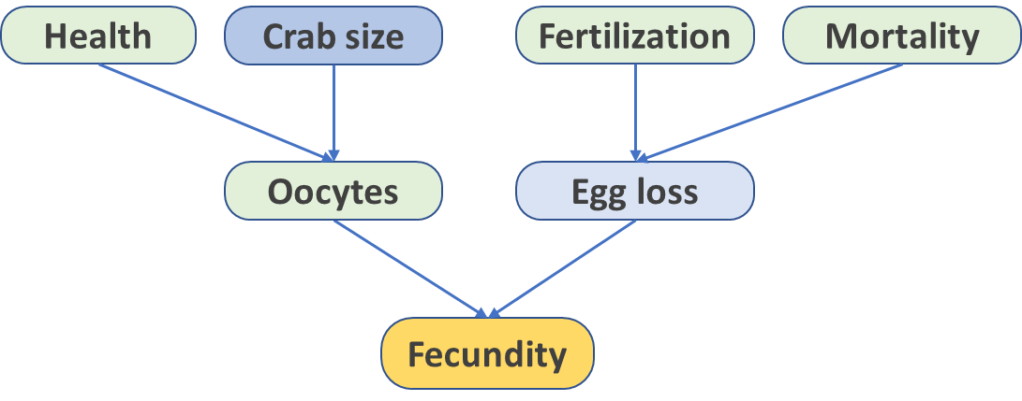
Figure 1 : Causal diagram for individual crab fecundity, expressed through oocyte production and egg loss after extrusion.

- Figure 1 shows a diagram of the main factors that influence individual fecundity in snow crab.
- There are two main factors affecting fecundity-at-size in snow crab.
  - The first factor is whether females are carrying their first (primiparous) or second or more clutch (multiparous).
    - Primiparous females are only 30-35% as fecund as their multiparous counterparts.
    - This difference is due to the oocytes of primiparous females being produced prior to the terminal moult. Thus the number of eggs which are extruded are a function of the pre-moult size, rather than their mature size.
  - The second factor is reductions in fecundity, seen especially among older females, which is either due to lower oocyte production or through egg loss during incubation. Such egg loss are variable and can range up to 70%.

Issues with past studies:
- For the most part, past studies have at least attempted to identify and control for spawning stage, generally by noting the carapace condition.
- Of the 15 snow crab studies we examined, carapace condition was noted in all of them, but most studies ended up not considering this variable as a predictor or as a reliable identifier of spawning stage.
- Only two studies, Sainte-Marie (1993) and Kon (2006), had a mixture of primiparous and multiparous females that the authors felt were identified with enough confidence to warrant each their own allometric curve.
- A few other studies had serendipitously sampled in areas with homogenous groups of females, either primiparous, as in Haynes et al. (1976), Jewett (1981) and Koltz (2015), or multiparous as in Comeau et al. (1999).
- these two factors in their sampling design by recording the condition of the carapace (to identify the spawning stage) and by noting or removing females with obvious reduced fecundity from their samples or analyses.

- It is critical to account for the spawning stage or reduced fecundity when analyzing snow crab fecundity observations.
  - Most studies attempt to identify spawning stage using carapace condition or the presence of grasping marks to separate primiparous from multiparous females.
    - However, such observations are subjective by nature and, even when consistently applied, are only able to partially differentiate between the two groups.
      - For example, while females with new-shelled carapaces are very likely to be primiparous in their first year of incubation, separating primiparous females in their 2nd year of incubation from young multiparous females is not trivial, as they may have similar carapace conditions.
  - Sometimes, studies will intentionally remove females with visible egg loss or showing other signs of senility.
    - While this method would help in targeting full-clutched females, the selection procedure is subjective and moreover introduces a selection bias which affects the very variable (fecundity) we are trying to model.
- Given the challenge to properly account for these variables, field samples are very likely to be of mixed composition, e.g. primiparous and multiparous females mixed together, with some proportion of them, especially older females, having reduced fecundity.
- Analyzing such mixed samples means that any variations in fecundity that are observed are likely due to demographic variations in the areas sampled, and not true changes in the underlying biological categories.
Modelling approach:
- While carapace condition will be used to partially inform spawning stage, we model the uncertainty of spawning stage identification within the analysis.
- We also address the issue of reduced fecundity by modelling the observed fecundities as a mixture of full-clutched females and females which have varying degrees of reduced fecundity. Again, the loss is not known beforehand, but is rather inferred from deviations from the “full-clutched” state.
- We develop a Bayesian hierarchical model. This approach allows us to extract the global patterns in the data, which then properly frames the analyses at the smaller, local scales.
Goals of our study:
- Provide fitted fecundity curves which account for maturity stage (primiparous and multiparous) and egg loss among old-shelled females.
- Account for uncertainties in maturity stage identification and characterizing which females are full-clutched versus those which have sustained significant egg loss.
- Examine the biological implications of the patterns that we observed in the data:
  - Differences between primiparous and multiparous.
  - Pubescent growth as an explanatory mechanism.
  - Shell condition is insufficient to completely identify P/M.
  - Senility also varies by size and shell condition.
- Once the main factors are accounted for:
  - Examine annual fecundity variations in Cape Breton (Bradelle and Baie des Chaleurs).
  - Is there evidence of variation?

Methodology:
Data set:
- Mature female snow crab from the sGSL were sampled to estimate individual fecundity starting in 1986 and last sampled in 2022 in the sGSL.
- These were all observational studies made on board chartered fishing or DFO Coast Guard vessels, using traps or trawls, with the latter used the annual sGSL snow crab survey.
- Live females or their egg pouches were kept on ice or frozen and brought to the lab for analysis.
- Egg pouches were removed and preserved with a dilute formalin solution or frozen.

- At the laboratory, each egg pouch was first dried for a minimum of 24h at 60°C. Eggs were then separated from the pleopods and any visible debris was removed.
- These cleaned eggs were then redried and a small sample of 500-1000 eggs was extracted, counted and weighed.
- The total dry egg weight of the clutch was then divided by the average egg weight obtained from the sample to estimate individual fecundity of each female.

- For each female, carapace width (CW) was measured to the nearest 0.1 mm, with the exception of older measurements prior to 1991, for which CW was measured to the nearest millimeter.
- Shell condition was determined for each female, based on a scale from 1 to 5 (ref), which was used to approximate the number of years that the female had molted.
- Shell conditions 1 & 2 (new softer-shelled crab) were considered to have molted within the current year, shell condition 3 (new hard-shelled crab) and shell conditions 4 (old hard-shelled) and 5 (old-shelled) were considered to have molted two or more years prior.

- Samples were grouped by year and grouped by geographical area: Baie des Chaleurs, Shediac Valley, Bradelle Bank and western Cape Breton.
- About 8% of samples were in other areas of the sGSL: north of Prince Edward Island (PEI) in the earliest studies in 1986 and 1987, and from scattered sites sampled during the snow crab survey in 2001-2005.
- In all there were 52 different year-region combinations, plus 6 datasets that were from other areas of the sGSL (Table X).

- In all there were 9195 fecundity determinations in the dataset,
- A small portion of the original data were removed from analysis based on obvious errors in egg sample weights (n = 52), or females with damaged or malformed abdomens, or eggs that had begun hatching (n = 61).
- Crab with carapace width smaller than 40 mm or larger than 95 mm were also removed (n = 15).
- Fecundities ranged from 5745 (48mm CW) to 134754 (81 mm CW) eggs per female.

- Among the other measurements which were often taken were a visual assessment of gonad color (white, beige or shades of orange) and egg color (light or dark orange).
- Gonad weights were measured for 2011 females.
Table X : Summary of the number of fecundity observations by year and region. Parentheses indicate month of sampling.
Year | other | Baie des Chaleurs | Shediac Valley | Bradelle Bank | Cape Breton
1986 | 85 (Jul,May) | 87 (May) | 0 | 0 | 68 (Aug)
1987 | 26 (Jul) | 0 | 0 | 0 | 0
1988 | 0 | 0 | 0 | 96 (Jun) | 0
1989 | 0 | 135 (May-Nov) | 0 | 58 (May,Aug) | 191 (Jun-Oct)
1990 | 0 | 324 (May-Nov) | 0 | 94 (Jun) | 0
1991 | 0 | 149 (May-Nov) | 0 | 0 | 0
1992 | 0 | 152 (Jul-Nov) | 0 | 0 | 0
1998 | 0 | 38 (Aug) | 0 | 236 (Jul) | 44 (Jul)
1999 | 0 | 213 (Mar) | 0 | 0 | 0
2001 | 40 (Aug,Sep) | 0 | 638 (Aug,Sep,Nov) | 0 | 130 (Sep)
2002 | 0 | 146 (Nov) | 319 (Jun,Aug,Nov) | 0 | 0
2003 | 119 (Aug) | 0 | 769 (Sep,Nov) | 0 | 310 (Sep,Oct)
2004 | 357 (Jul,Aug) | 0 | 0 | 0 | 95 (Oct)
2005 | 112 (Jul-Sep) | 46 (Jul,Aug) | 79 (Jul,Aug) | 0 | 57 (Sep)
2006 | 0 | 130 (Aug,Sep) | 0 | 0 | 273 (May,Jun,Aug)
2007 | 0 | 0 | 0 | 305 (Aug) | 211 (Jun,Sep)
2008 | 0 | 89 (Aug) | 0 | 232 (Jul,Sep) | 271 (Jun,Sep)
2009 | 0 | 230 (Aug,Sep) | 0 | 119 (Aug) | 254 (Jun,Sep)
2010 | 0 | 163 (Aug) | 0 | 400 (Jul,Aug) | 198 (Sep)
2012 | 0 | 0 | 0 | 106 (Aug) | 0
2013 | 0 | 18 (May) | 0 | 0 | 129 (Jun,Oct,Nov)
2015 | 0 | 0 | 0 | 0 | 188 (Oct,Sep)
2017 | 0 | 69 (Jun) | 0 | 72 (Jun) | 69 (Aug)
2018 | 0 | 12 (May) | 0 | 25 (Jun) | 92 (Aug)
2019 | 0 | 85 (Jun) | 0 | 84 (Jun) | 75 (Aug)
2021 | 0 | 0 | 0 | 0 | 71 (Jul)
2022 | 0 | 28 (May) | 0 | 0 | 0

Issues with current methods:
- Identifying spawning stage is difficult.
- Different methods are used to separate primiparous from multiparous females in stock assessments and the snow crab literature.
  - In order of common usage, these are shell condition, the presence of fresh grasping marks, and inspection of spermathecal contents (Sainte-Marie, 1993).
- These methods are accurate to some degree however, shell condition and grasping marks are measures that require subjective interpretations by technicians.
- Inspection of spermathecal contents may be more reliable, although it require dissection of the crab.
- Where these methods become problematic is the presence of a biennial reproductive cycle, as the characteristics of a primiparous female in its second year of incubation are hard to distinguish from a new multiparous female in its first year of incubation.
- This would mean their shell conditions, for instance, would be similar, i.e. clean and hard-shelled.
How our approach deals with these issues:
- In this paper, we use a combination of shell condition and individual fecundity to more clearly distinguish between primiparous and multiparous females.
- Our model was constructed, based on the following assumptions, which address some of the uncertainties highlighted above. Thus, we assume that:
  - Primiparous fecundity is markedly lower than a typical healthy multiparous female.
  - Shell conditions 1 & 2 (new-shelled crab) are very likely to be primiparous, based on the fact that they likely moulted in the current year.
  - Shell condition 3 crab are made up of a mixture of primiparous females in their 2nd year of incubation or newly multiparous females in their 1st year of incubation.
- Present data set:
  - Table of location x year containing information on sample size/composition (shell condition).
  - Review locations with Renee (e.g. 2002 locations in Shediac Valley).
  - Discuss seasonal variations in sampling.
  - Discuss limits of observational data when trying to draw conclusions.
  - Map of sample locations.
  - Discuss observational biases.
    - Dropped eggs
    - Missing pleopods
    - Sampling of only full-clutched females.
    - Sampling of only multiparous females.
Main goals:
- Aggregate analysis:
  - Produce reference curves equations for primiparous and full-clutch multiparous females.
  - Show and provide reference line cut-off for distinguishing between full-clutch and reduced-clutch multiparous females.
  - Shell condition category breakdown:
    - SC2 data:
      - High fecundity outliers are likely misclassified shell conditions.
      - Low fecundity outliers are either real outliers or low actual rates of egg loss.
    - SC3 data:
      - Primiparous implies that they are in their second year of incubation. Highlight areas/times where these were caught.
      - Multiparous implies that these are in the first year of their second clutch, but that they likely had a one year cycle when they were primiparous.
    - SC4 data:
      - Egg loss (reduced fecundity) prevalence and fraction lost.
    - SC5 data:
      - Are reduced fecundity rates much higher senile females?
  - Contrast relative fecundity between primiparous and full-clutched multiparous females.
    - What is the likely mechanism that explains why primiparous females have fewer eggs?
    - If we were able to revert primiparous females to their pre-moult sizes, would their fecundity be on par will that of full-clutched females?
  - Compare your fecundity data and fitted regression lines to the literature:
    - Compile table of fecundity studies and locations, showing the sample sizes, maturity identification, egg loss consideration, and the resulting fitted model.
  - Perform individual egg dry weight comparison:
    - Contrast primiparous, multiparous females (full and reduced clutch).
    - Are there seasonal/regional differences?

Problem scoping:
Define the problem to be addressed and its scope, including the
- the function of purpose of modelling,
  - estimate primiparous and multiparous fecundity curves for female snow crab in the sGSL.
  - account for uncertainty in the maturity stage identification, and allow for possible lower egg production/egg loss among older multiparous females.
  - quantify the prevalence and fraction of lower fecundity among older (multiparous) females in our samples.
  - account for nuisance variables so that we may better detect the impact of variables of interest. Provide a framework for building more complex models (e.g. spatio-temporal).
  - account for outliers in the data.
- the system boundaries,
  - within different areas of the sGSL.
  - disparate studies with different sampling, goals and observational protocols.
  - from 1986 to 2022.
  - same supervision (coauthor).
  - identify unobserved factors which are likely affecting fecundity.
- the issues or questions to be addressed, and
  - wide range of crab sizes.
  - synthesis of a lot of data.
  - How to best standardize the data.
  - Provides a deeper look into main drivers of fecundity that are sometimes confused with population or spatio-temporal differences.
- the stakeholders to be engaged.
  - snow crab stock assessment biologists/population or egg production modelers.
  - snow crab biologists looking to analyze their fecundity data sets or compare their local fecundity results.
Clarify
- the end-user context (user and management needs),
  - provide individual fecundity estimates for different female snow crab groups.
  - Suitable for egg production modeling.
- problem context (nature of the problem and how well it’s understood) and
  - Snow crab fecundity is standard fare in the literature, and differences between primiparous and multiparous have long been known.
  - Fitted curves are generally allometric, although sometimes they are linear.
  - Data sets are often small and likely heterogenous (i.e. with different maturity stages or egg loss), which can lead to limited use or biological inference.
  - The allometric power coefficient should generally be close to 3, although it often deviates significantly in some studies. This may lead to issues if such curves are used outside of the size range of the original data set.
  - Nuisance factors are generally treated in an ad hoc manner, with visible outliers being removed beforehand, or females with visible reduced fecundity being subjectively removed or left unsampled.
- project context (resources available such as time, funding, skills and data).
  - Department of Fisheries and Oceans project. Made with chartered vessels and Canadian Coast Guard vessels, sampling in different areas of the sGSL from 1986 to 2022.
  - Our study benefits from a large data set, with a order of magnitude more data than typical studies.
  - Part of a long-running study under one of the co-authors (Moriyasu) looking into spatial and temporal changes in crab condition, fecundity and maturation.

Problem conceptualization:
- Build the evidence base (e.g. expert and stakeholder knowledge, and relevant literature, data, models and hypotheses) to conceptualize the problem or system, generally in a qualitative sense.
- Include identifying key variables, indicators, processes, relationships, entities and scales, as well as metrics around model performance.
Model formulation and evaluation:
- Include formal description of the model, its implementation as some computer software, and the software testing.
- Selection of the modeling approach, construction of the model structure, calibration of its parameters, uncertainty analysis, model testing and evaluation.

Approach:
- This data set is large and spans a wide timeline, and various studies in different areas and using different sampling and laboratory protocols.
- Data stem from the southern Gulf of Saint Lawrence.
- Shell conditions were identified using the scale of 1 to 5 for most of the series.
  - Shell conditions in the earliest part of the series were only identified as new-soft, new-hard shelled, and old-shelled (pre-1990). These were mapped onto shell conditions 2, 3 and 4, respectively.
- Data with missing or unreliable carapace widths measurements, fecundity determinations or shell conditions were removed from the analysis (1460 observations).

Results:
Data summary:
A scatterplot of the entire fecundity dataset, separated by shell condition, is shown in Figure X.
What we see in our dataset:
- Two distinct fecundity groups are clearly visible, separated by a small but visible gap.
- New-shelled crab (shell conditions 1 & 2) were almost exclusively associated with the lower fecundity group.
- Shell condition 3 (clean hard-shelled) crab were mainly associated with the lower fecundity group, but also had a fair proportion that was associated with the higher fecundity group.
- Shell condition 4 & 5 crab made up most of the higher fecundity group, but there was also a fair proportion that had lower fecundity, producing a diffuse cloud of points that overlapped and even fell below the lower fecundity group.
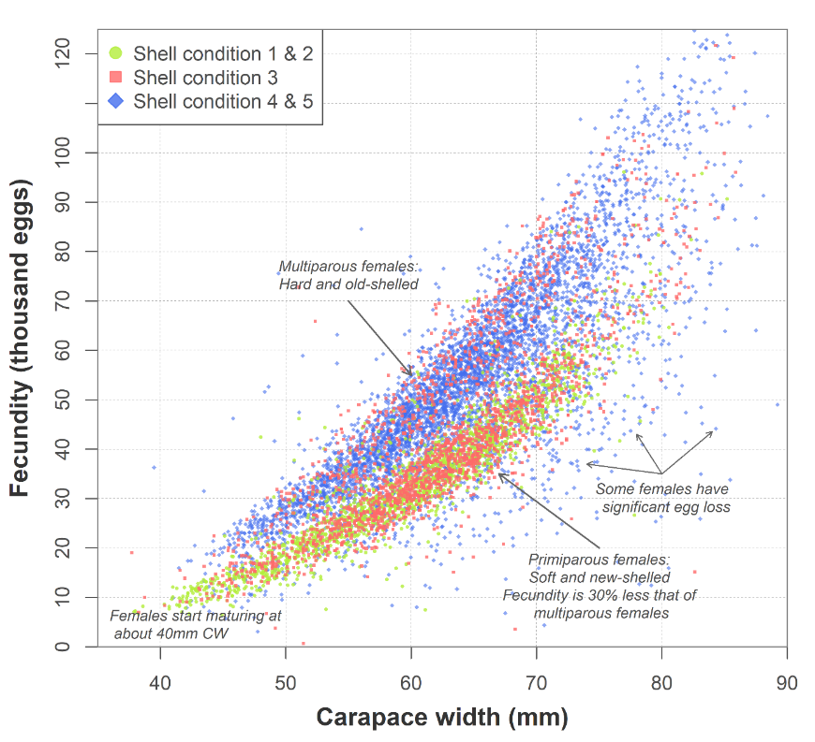
Figure X : Scatterplot of snow crab fecundity versus carapace width for the complete dataset. Colours indicate shell condition.

- Another way to examine how fecundity varies with shell condition is through histograms of fecundity on the log-scale, relative to a chosen reference line (Figure Y).
- From this figure, we see that:
  - There are two clear modes in the fecundity data, corresponding to the lower and higher fecundity groups observed in Figure X.
  - The majority of SC 1 & 2 crab lie in the lower fecundity group.
  - SC3 crab have a bimodal distribution, lying in both fecundity groups.
  - SC4 crab have a unimodal distribution, making up most of the higher fecundity group, but also showing a tapering tail of reduced-fecundities which extends through and even beyond the lower fecundity group.
  - The lower mode of SC3 crab lines with the lower fecundity mode of SC 1 & 2 crab, while its upper mode lines with the higher fecundity mode of SC 4 & 5.
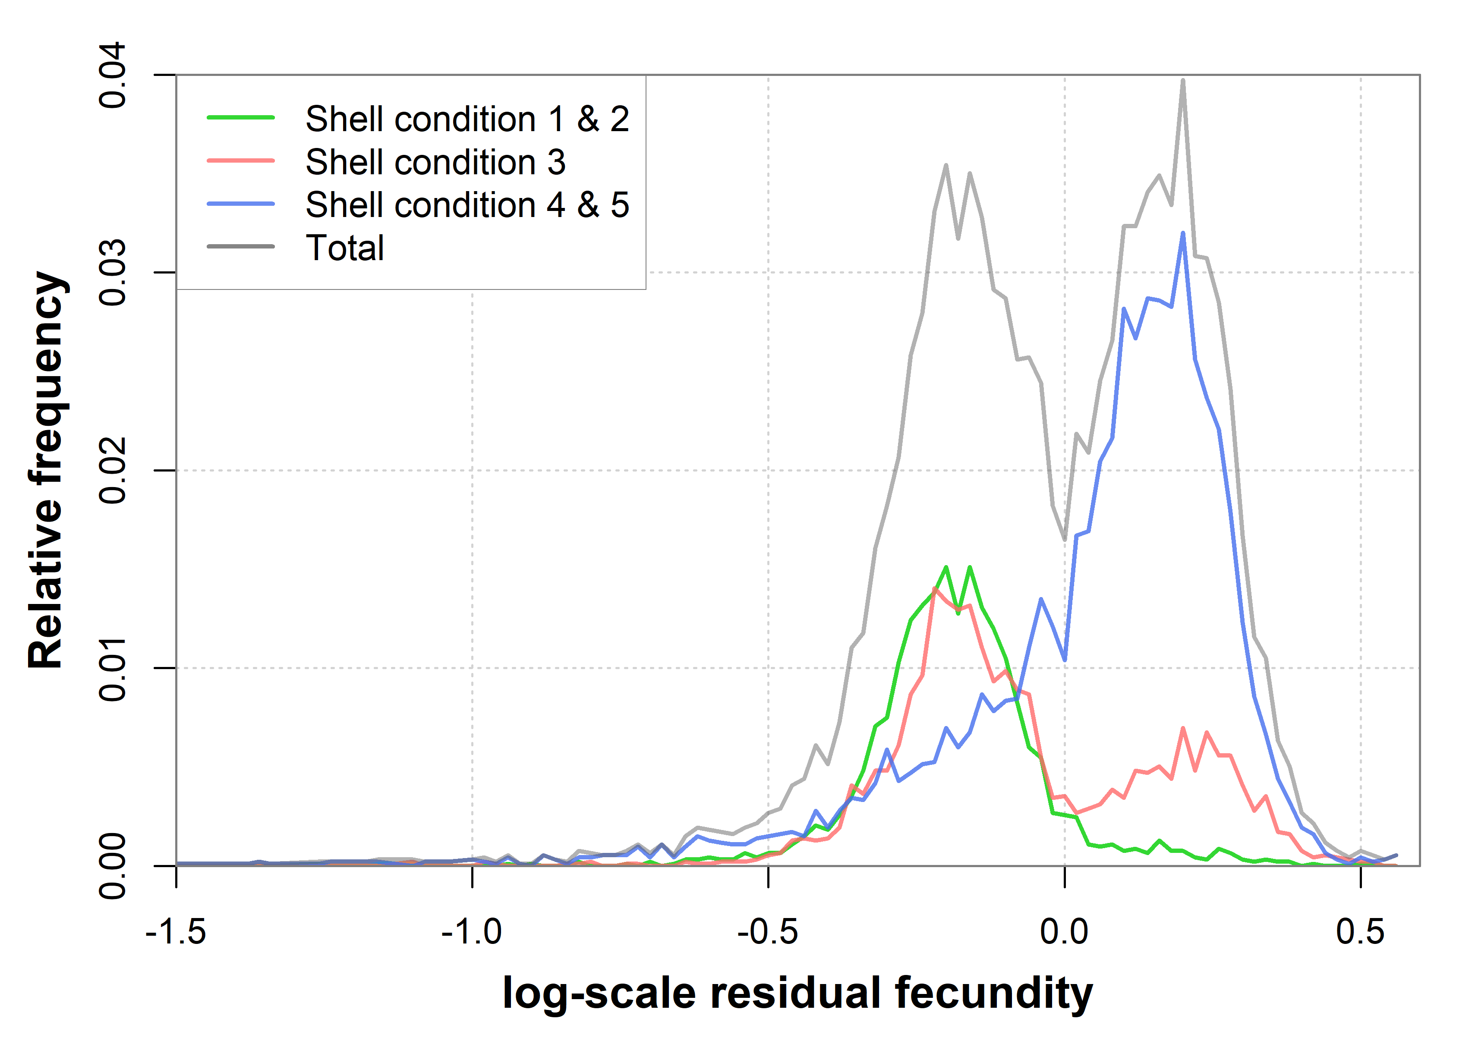
Figure X : Relative frequency distribution of log-scale fecundities around a reference line $\ln{y}=3ln{x}+1.72$, where $x$ is the carapace width in millimeters and $y$ is the observed fecundity. The reference line was chosen to lie between the lower and upper fecundity groups. The green, red, and blue lines indicate shell conditions and the grey line shows the distribution of the combined data. Profile vue of the relative distribution of fecundities by shell condition.

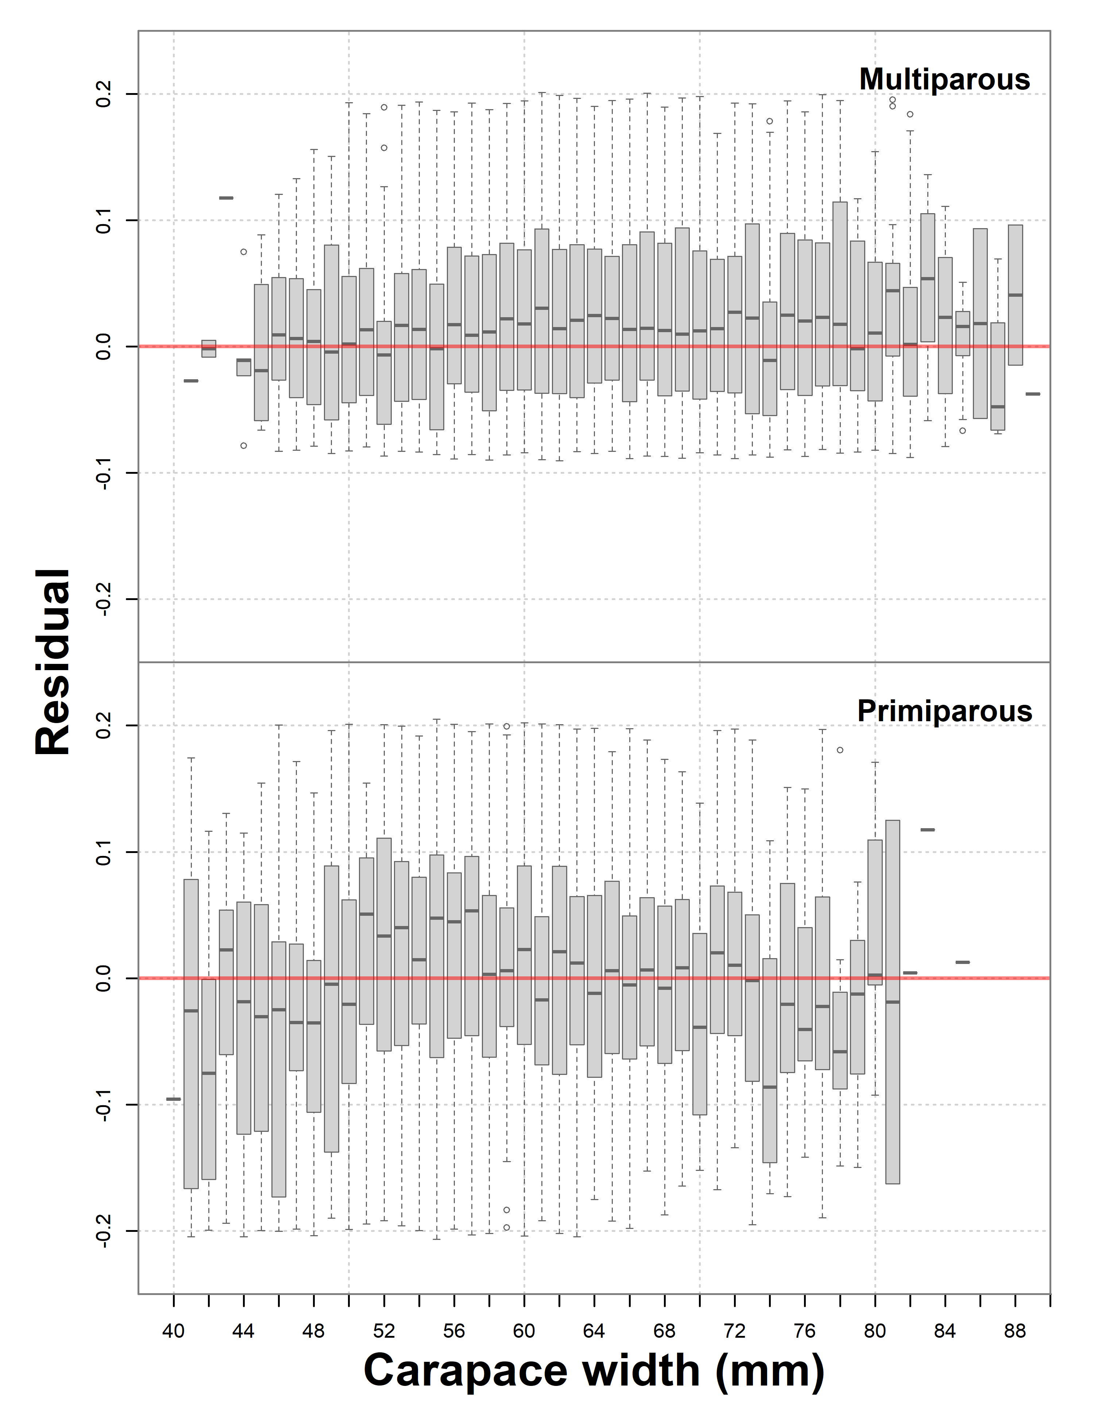
Figure X : Fecundity residual plot (log-scale) for primiparous (bottom panel) and multiparous (top panel).

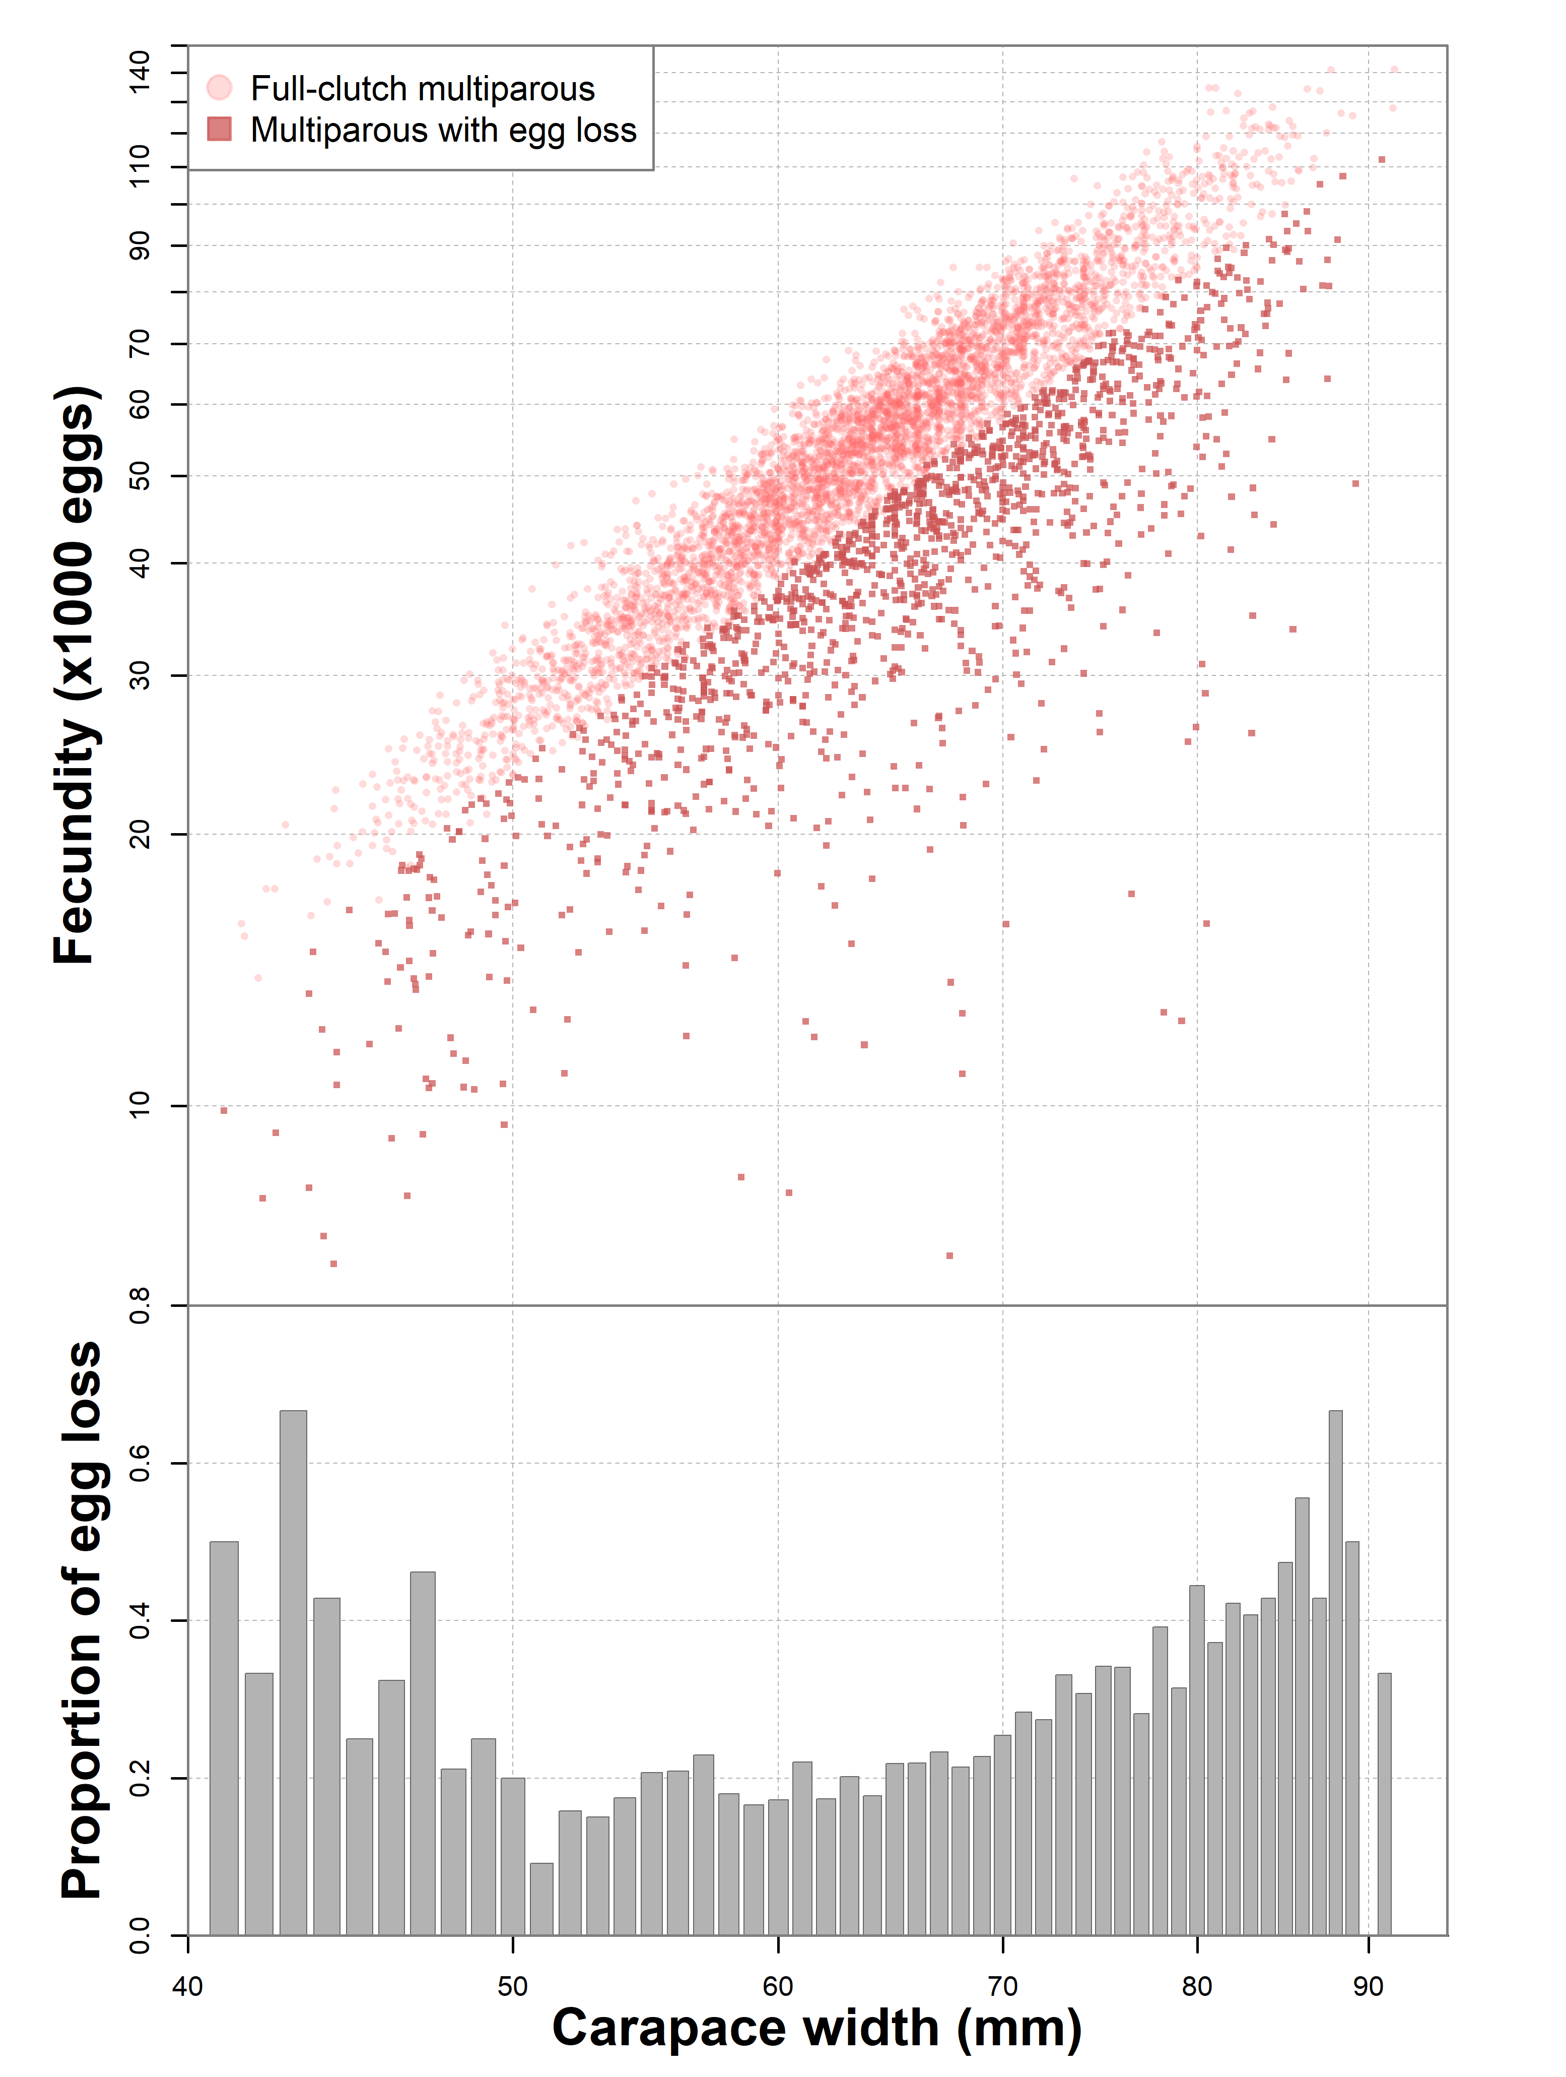
Figure X : Fecundity of multiparous females with full-clutched and egg loss with carapace width (top panel). Observations identified as primiparous were removed. Proportion of multiparous females having had egg loss in our samples versus carapace width.
- Multiparous females with egg loss show quite a wide range of fecundities, which overlaps substantially with that of primiparous females.
- The proportion of egg loss in our samples, except for the smaller females, generally increased from a bit lower than 20% to 40% at larger sizes.

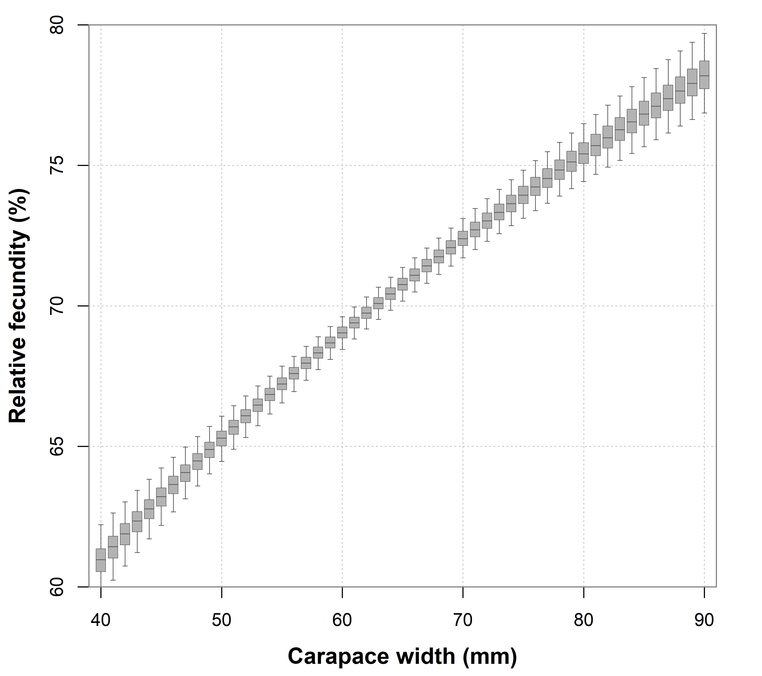
Figure X : Relative fecundity of primiparous versus full-clutched multiparous females inferred from posterior samples from the Bayesian model.
- On average, primiparous fecundity is about 30% lower than that of full-clutched females, but in practice, fecundity ranges from 35% lower at the smaller sizes to 25% lower for larger sizes.

Discussion:
How do we interpret these patterns biologically?
- Based on these observations, we interpret that the lower fecundity group, composed of a well-defined cluster of points made up of shell condition 2s and 3s, are primiparous.
  - Shell condition 2 are interpreted as being in their first year of clutch incubation, whereas shell condition 3s are likely primiparous females in their second year of incubation.
  - There are very few shell condition 2s that lie outside (either above or below) the tight aggregation seen on the scatterplot.
- We interpret shell condition 3s overlapping the high fecundity group, as being multiparous females (second clutch) in their first year of incubation.
- Shell condition 4s and 5s are interpreted as multiparous incubating their second or more clutch of eggs.
- The distribution of multiparous fecundities is made up of a high fecundity group, plus a tapering tail of lower fecundity females that extends over that of primiparous females and even below it, i.e. some multiparous females have fecundities that are even lower than those of primiparous females.
Fecundity curve results:
- The fecundity model showed that primiparous females had an average 30% less eggs than full-clutch multiparous females.
- This figure is comparable to
- Assuming that the fecundity differences between primiparous and multiparous females are exclusively the result of changes in body size due to growth leads to the conclusion that pubescent to primiparous growth is on the order of an 11% in CW.
- This rate is modest by many reported rates in the literature …
- However, for the growth rate to be larger would imply that the difference in fecundity between the two groups be even larger.
- Indeed, the growth rate corresponding to two allometric with the same exponent is given by:

- Thus we see that the corresponding growth rate is a function of the alpha values, specifically their ratio.

- Thus we see that a 20% difference in fecundity as reported by Sainte-Marie is at odds with a 15% growth rate reported in the same region, since 20% corresponds to only a 7% growth rate, and a 15% growth rate would imply that primiparae at their pre-moult sizes were producing X% more eggs than a full-clutched multiparous of similar size.

What are the main model results?
- The allometric curves for primiparous and full-clutched multiparous females are shown in Figure X.
- The allometric power coefficient(s) lies close to three, as theoretical considerations dictate.
- Primiparous females were found to be only 70% as fecund as full-clutched multiparous females.
- We found that egg loss rates in our samples increased with size among multiparous females, with rates doubling from 50 to 70 mm CW, going from 15% up to 40% for larger sizes (Figure X).
- Though the model does not explicitly model it, we found that the multiparous females were separated by a allometric line :

Fecundity, stock dynamics and sampling:
- Each of the categories we have considered, i.e. primiparous and both full- and reduced-clutch multiparous females, are subject to fluctuate with the dynamics of a given snow crab population.
- For example, years with a strong cohort of females recruiting to maturity would have higher proportions of primiparous females, while a series of years with low levels of recruits would result in higher proportions of older multiparous females.

Making stock/population inferences from samples:
- There are many studies which report different fecundity curves from snow crab stocks around the world.
- Because mature female stocks are dynamic, the proportions of different maturity stages will vary significantly through time and space (since females show a strong tendency to aggregate by maturity in certain areas).
- Thus, it is critical to account for the maturity state of fecundity observations before fitting fecundity curves.
- Otherwise, the curves might only reflect the particular state of the stock and not its true biological characteristics.
- Most snow crab fecundity studies do not identify the maturity state.
  - There are different reasons for this…
  - It is hard to identify primiparous and multiparous.
  - We were only able to do so because of a shitload of data.
  - If the data set was smaller, the consistency of the primiparous and multiparous clouds would not have been evident.
- Of the studies that do separate by maturity, we have Kon et al. (2006) in the Sea of Japan and Sainte-Marie (1993) in the northern Gulf of Saint-Lawrence.
- Three other studies had either exclusively primiparous or multiparous samples. These are Comeau et al. (1999), which had a multiparous sample from a small bay in Newfoundland, along with two older studies from Alaska: Jewett (1981) which was composed of “new-shelled females” and Haynes (1976) which “were all first-time spawners”.

Snow crab egg production for a population:
- Producing an egg production estimate from our fitted seems complicated, given that

Fecundity monitoring:
- Failure to account for these effects might lead researchers to conclude that fecundity varies because of other factors.

- For monitoring, primiparous females, because of their ease of identifiability and apparent consistency of their fecundity levels, might constitute a better index than multiparous females, as the latter are more difficult to identify (e.g. shell condition 3s) as well as the complications brought about by egg loss in older females.

- Under the assumption that primiparous females are clearly identifiable (e.g. by shell conditions 1 & 2),
- i.e. we would expect that multiparous fecundity would vary significantly according to the proportion of younger/older females.
- Under environmental stressors or lack of available males, the fecundity of primiparous females might be expected to either decrease on average or that a portion would display signs of egg loss as observed in older multiparous females.
- There are fewer confounding variables (e.g. population dynamics) affecting primiparous, than for multiparous.

Implications for pubescent/primiparous growth:
A single model view:
- The extent of the separation between the fecundity of primiparous and full-clutched multiparous is largely a function of the size of the growth increment that pubescent females undergo when moulting to maturity.
- To see this, recall that oocyte production is constrained by body size and, because of the tight link between the moult to maturity and moulting in snow crab, the number of eggs among primiparae is considered to be a function of the number of oocytes produced during its pre-moult state.
- (This also implies that the number of oocytes produced should closely mirror the fecundity relation of full-clutched multiparous females).
- Small growth increments imply that the number of eggs a primiparous is higher relative to its size.
  - Thus for such females, when a second clutch is produced, the contrast between the its primiparous/multiparous fecundity is less pronounced.
- Conversely, larger growth increments lead to primiparous with lower fecundity relative to its size.
  - For these females, the primiparous/multiparous fecundity gap would be more pronounced.

Based on these ideas, we can infer pubescent/primiparous growth using primiparous and multiparous fecundity relations. See Annex X for mathematical details.
- An alternate way to consider the difference in fecundity between primiparous and full-clutch multiparous females is that there is in fact only one fecundity model, but that the primiparous females is interrupted by a molt.
- In other words, we could have only a multiparous fecundity model, and adjust the sizes of primiparae to make their fecundity “line up” to that of their multiparous counterparts.
- We thus have one fecundity model and one growth model to back-transform primiparae to their original sizes.
Biological perspectives:
Literature review of snow crab studies:
- What are the main purposes of snow crab fecundity studies?
  - Characterizing the fecundity relations of their local populations.
  - Comparison through time/space (some regional comparisons, and some seasonal).
  - Egg production models (population level).
- Large-scale (disaster) monitoring – using eggs remaining on surveys.
  - Used to provide coarse fecundity assessment. Should trigger if a serious change in clutch size occurs. Unable to monitor subtle or small-scale variations effectively.
- Few population-level egg production models.

Snow crab fecundity may not be as variable between stocks as is reported:
- Most of the differences in fecundity relationships could be explained away by small sample size, heterogeneity of sampling, or differences in lab protocol.
- A simulation study using our dataset, using small sample sizes showed that the resulting power coefficients had a 95% confidence region that encompassed those of most other studies.
- Localized studies are more likely to contain homogeneous samples, but with small sample sizes, just a few data points can skew the regression (e.g. some females with reduced fecundity, or from another spawning stage.

Table X : Summary table of studies with fecundity relations based on samples with identified spawning stage. In the equations $x$ indicates the carapace with in millimeters.
Study | Location | Maturity | Description | n | Equation | Size range (mm)
Haynes et al (1976) | Bering Sea, Alaska | Primiparous | “first time spawners” | 23 | $$0.4905 x^{2.7206}$$ | 55-80 mm CW
Jewett et al. (1981) | Chukchi Sea, Alaska | Primiparous | “new-shelled” | 63 | $$0.0249 x^{3.4822}$$ | 40-63 mm CW
Sainte-Marie (1993) | Northern Gulf of St. Lawrence | Primiparous | “new recruit” | 75 | $$0.2328 x^{2.948}$$ | 40-80 mm CW
Sainte-Marie (1993) | Northern Gulf of St. Lawrence | Multiparous | “old recruit” | 81 | $$1.7989 x^{2.506}$$ | 40-80 mm CW
Comeau et al. (1999) | Western Newfoundland | Multiparous | “Hard-shelled orange eggs” | 53 | $$0.2665 x^{2.9486}$$ | 55-81 mm CW
Kon & Adachi (2006) | Wakasa Bay, Sea of Japan | Primiparous | “primary spawners” | 98 | $$3063.4x-170904$$ | 73-97 mm CW
Kon & Adachi (2006) | Wakasa Bay, Sea of Japan | Multiparous | “young repeat spawners” | 25 | $$4498.4x-248393$$ | 74-91 mm CW
Kolts et al. (2015) | Northern Bering Sea | Primiparous  (mainly) |  | 66 | 0.0292 CW^3.4026 | 40-68 mm CW

Study characteristics:
- Studies differed in the manner that individual fecundity was calculated and their sample preservation methods.
  - Since counting the entire
- The number of fecundity observations generally ranged from 25 up to a few hundred.
- Not all studies used the allometric model, with some opting to fit fecundity as a linear function of size.

References:
Alunno-Bruscia, Marianne, Sainte-Marie, Bernard. 1998. Abdomen allometry, ovary development, and growth of female snow crab, Chionoecetes opilio (Brachyura, Majidae), in the northwestern Gulf of St. Lawrence. Canadian Journal of Fisheries and Aquatic Sciences. 55(2): 459-477. https://doi.org/10.1139/f97-241.
Burmeister, A. 2002. Preliminary notes on the reproductive condition of mature female snow crabs (Chionoecetes opilio) from Disko Bay and Sisimiut, West Greenland. In: Crabs in cold water regions: biology, management, and economics (A.J. Paul, E.G. Dawe, R. Elner, G.S. Jamieson, G.H. Kruse, R.S. Otto, B. Sainte-Marie, T.C. Shirley & D. Woodby, eds.), pp. 255–267. Alaska Sea Grant College Program, Fairbanks, AK, USA.
Comeau, M., Starr, M., Conan, G.Y., Robichaud, G. & Therriault, J.-C. 1999. Fecundity and duration of egg incubation for multiparous female snow crabs (Chionoecetes opilio) in the fjord of Bonne Bay, Newfoundland. Canadian Journal of Fisheries and Aquatic Sciences, 56: 1088–1095.
G.Y. Conan, Moriyasu, M., D.R. Maynard and Y.J.Chiasson. 1989. Factors influencing egg production in decapod Crustacea with two case studies: Chionoecetes opilio and Homarus americanus in the Gulf of St. Lawrence (Canada). International Council for the Exploration of the Sea. CM 1989/04.
Hanna E H Danielsen, Ann M Hjelset, Bodil A Bluhm, Carsten Hvingel, Ann-Lisbeth Agnalt, 2019. A first fecundity study of the female snow crab Chionoecetes opilio Fabricius, 1788 (Decapoda: Brachyura: Oregoniidae) of the newly established population in the Barents Sea, Journal of Crustacean Biology, 39(4), Pages 485–492, https://doi.org/10.1093/jcbiol/ruz039.
Elner, R. & Beninger, P.G. 1992. The reproductive biology of Snow Crab, Chionoecetes opilio: a synthesis of recent contributions. American Zoologist, 32: 524–533.
Elner, R.W., Gass, C., 1984. Observations on the reproductive condition of female snow crabs from N. W. Cape Breton Island, November 1983. Can. Atl. Fish. Sci. Adv. Comm. Res. Doc. 84/14.
Haynes, Evan, Karinen, John F. Watson, Jeffrey, and Hopson, Daniel J. 1976. Relation of Number of Eggs and Egg Length to Carapace Width in the Brachyuran Crabs Chionoecetes bairdi and C. opilio from the Southeastern Bering Sea and C. opilio from the Gulf of St. Lawrence. Journal of the Fisheries Research Board of Canada. 33(11): 2592-2595. https://doi.org/10.1139/f76-304.
Jewett, S. 1981. Variations in some reproductive aspects of female snow crabs Chionoecetes opilio. Journal of Shellfish Research, 1: 95–99.
Kolts, J.M., Lovvorn, J.R., North, C.A. & Janout, M.A. 2015. Oceanographic and demographic mechanisms affecting population structure of snow crabs in the northern Bering Sea. Marine Ecology Progress Series, 518: 193–208.
Mäntyniemi, Samu, Romakkaniemi, Atso and Arjas, Elja. 2016. Bayesian Estimation of the Number of Individuals in a Sample with a Known Weight. J. Aquat. Mar. Biol. 4(5): 00095. DOI: 10.15406/jamb.2016.04.00095.
Murphy , James T., Rugolo, Louis J., Turnock, Benjamin J. 2017. Integrating demographic and environmental variables to calculate an egg production index for the Eastern Bering Sea snow crab (Chionoecetes opilio), Fisheries Research, 193:143-157. ISSN 0165-7836, https://doi.org/10.1016/j.fishres.2017.04.003.
Paul, J.M., Paul, A.J., and Barber, W.E. 1997. Reproductive biology and distribution of the snow crab from the northeastern Chukchi Sea, pp. 287-294. In Reynolds, J. (ed.), Fish ecology in Arctic North America. Amer. Fish. Soc. Symp. 19.
Sainte-Marie, Bernard. 1993. Reproductive Cycle and Fecundity of Primiparous and Multiparous Female Snow Crab, Chionoecetes opilio, in the Northwest Gulf of Saint Lawrence. Canadian Journal of Fisheries and Aquatic Sciences. 50(10): 2147-2156. https://doi.org/10.1139/f93-240
Sainte-Marie, B., Carriere, C., 1995. Fertilization of the second clutch of eggs of snow crab, Chionoecetes opilio, from females mated once or twice after their molt to maturity. Fish. Bull. 93, 759–764.
Taylor, David M. 1996. Aspects of multiparous snow crab (Chionoecetes opilio) fecundity in insular Newfoundland waters. Master’s Thesis, Memorial University of Newfoundland
Webb, Joel B., Slater, Laura M., Eckert, Ginny L., and Kruse, Gordon H. 2016. The contribution of fecundity and embryo quality to reproductive potential of eastern Bering Sea snow crab (Chionoecetes opilio). Canadian Journal of Fisheries and Aquatic Sciences. 73(12): 1800-1814. https://doi.org/10.1139/cjfas-2015-0485

Annex A : Validation of modeling assumptions using gonad weight data
- Gonad characteristics, such as weight, color, and oocyte size (Gardner et al. 2021), as well as egg development can be used to infer the incubation year for eggs. Egg development stages (Moriyasu et al. ) and proxies (egg color) can also be used.
- This is an exercise to see if the some of the patterns we perceived using shell condition and fecundity levels are consistent with observed gonad weight variations within our dataset. We treat the gonad weight method as more reliable.
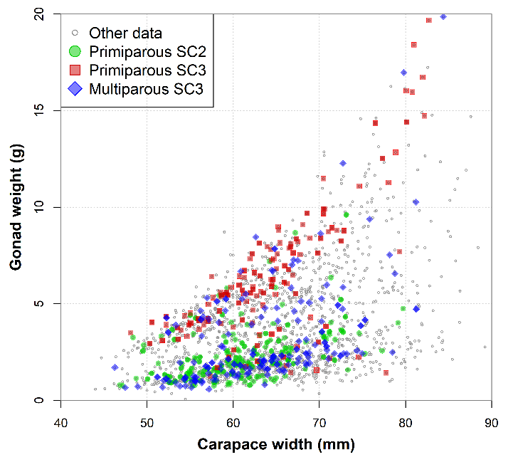
Figure X : Plot of gonad weight versus carapace width from our dataset (n = 2043, black circles). Samples were taken from May to November. There are two main clouds of points: smaller, developing gonads lie in the lower cloud, and are subject to increase somewhat over the season, while larger, fuller gonads lie in the upper cloud, and are more stable over the season. Small gonads are associated with females having laid eggs during the current year, while larger gonads are associated with females incubating their eggs for a second year (biennial cycle). Colored points represent different combinations of spawning stage and shell condition.

Table X : Summary table of inferences from consideration of gonad weight variations and different maturity stage / shell condition combinations, including incubation year and age of the carapace.
Stage | SC | Gonad | Incubation | Carapace age | Issue
Primiparous | 2 | Small | 1st year | < 1 year
Primiparous | 2 | Large | 2nd year | 1 - 2 years | Misclassified SC3s.
Primiparous | 3 | Small | 1st year | < 1 year | Misclassified SC2s.
Primiparous | 3 | Large | 2nd year | 1 - 2 years
Multiparous | 3 | Small | 1st year | 1 - 3 years
Multiparous | 3 | Large | 2nd year | 3 - 4 years | Misclassified SC4s.

- Shell conditions identification issues highlighted here do not raise any major issues with our spawning stage inferences (primiparous and multiparous) since we did not count on shell condition being reliable: we allowed shell condition 2s to be 1st or 2nd year primiparous, shell condition 3s to be either primiparous or multiparous, depending on their fecundity level.
Annex B : Dry egg weight analysis
- Drivers:
  - Egg size.
  - Egg lipid content
  - Crab health
- Nuisance effects:
  - Egg damage (e.g. from being frozen).
  - Humidity content
  - Pleopod hairs and debris content
- Observed predictors:
  - Maturity stage: observable difference between primiparous (lower weight )and multiparous (higher weight).
  - Fecundity: Observable difference between low and high fecundity crab.
  - Shell condition
    - SC3 crab: Primiparous (2nd year of incubation) is lower than multiparous (1st year of incubation).
  - Egg color:
    - Among primiparae, dry egg weight seems slightly less for dark orange eggs.
    - Among multiparae, dry egg weight does not seem different for light and dark eggs.
  - Month:
    - Does egg weight vary by month? Stick to cases where we can infer incubation year.
  - Egg loss: Egg loss and reduced fecundity seem to be correlated (i.e. health indicator?).

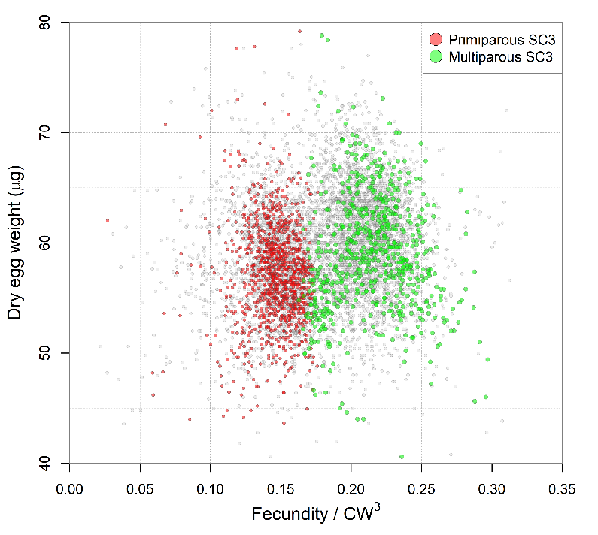

Annex C : Mathematical relationship between primiparous fecundity and growth
Let the pubescent to primiparous growth be expressed as
$$x_{t+1}=bx_{t}+a$$
then the allometric relation for primiparous fecundity is
$$y=α{\left(\frac{x_{t+1}-a}{b}\right)}^{β}$$
where $x_{t+1}$ is the primiparous carapace width $α$ and $β$ are the allometric coefficients for a full-clutch multiparous female.
If we assume that the growth increment is proportional, then $a=0$, and the equation reduces to:
$$y=\frac{α{x_{t+1}}^{β}}{b^{β}}$$
which can be seen to be the multiparous fecundity relation $α{x_{t+1}}^{β}$, scaled down by the growth factor $b>1$. From this, we can calculate the difference in fecundity between primiparous and multiparous.
The difference in fecundity can be shown to be
$$1-\frac{1}{b^{β}}$$
Pubescent growth was about 12-15% in Mikio’s dataset and 16-18% in the Alunno-Bruscia et al. (1998) laboratory growth dataset.
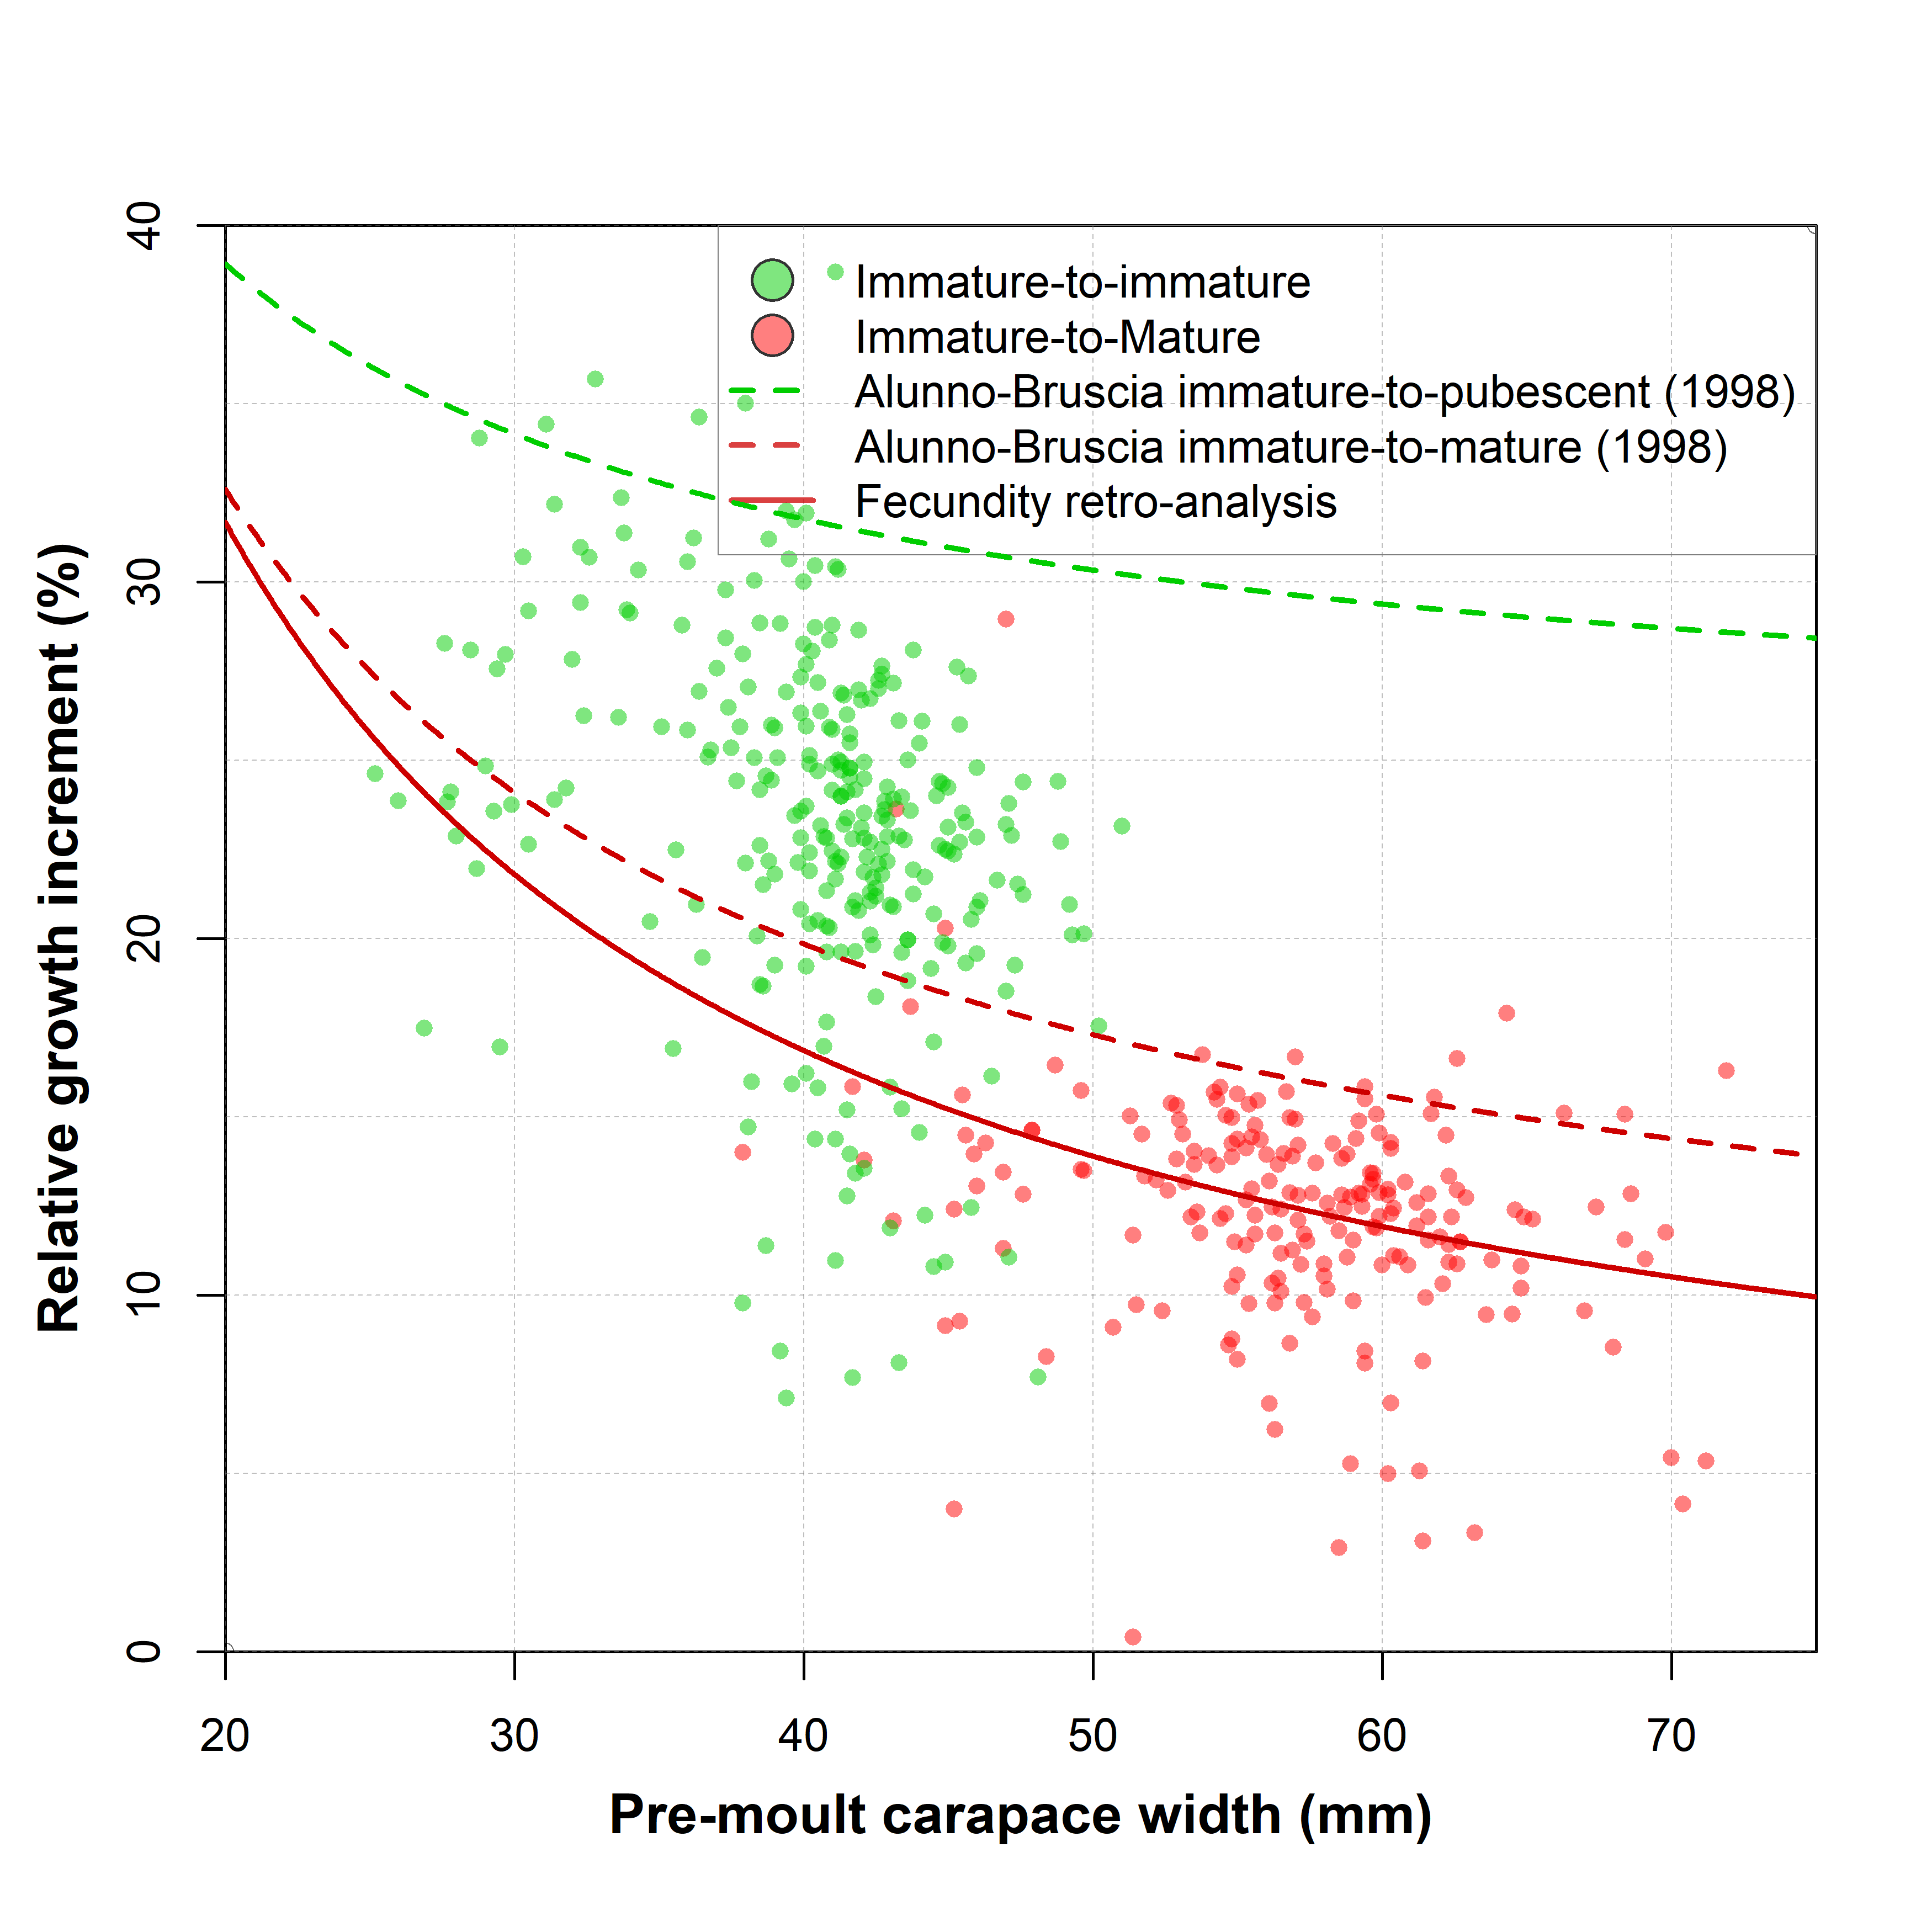
Figure X : Relative growth rates from archival laboratory growth data (Moriyasu 2002) for immature-to-immature (green points), and pubescent-to-primiparous (red points) molting. Curves represent reported or estimated growth models, which are linear functions of pre-moult size, but are curves on the relative scale.
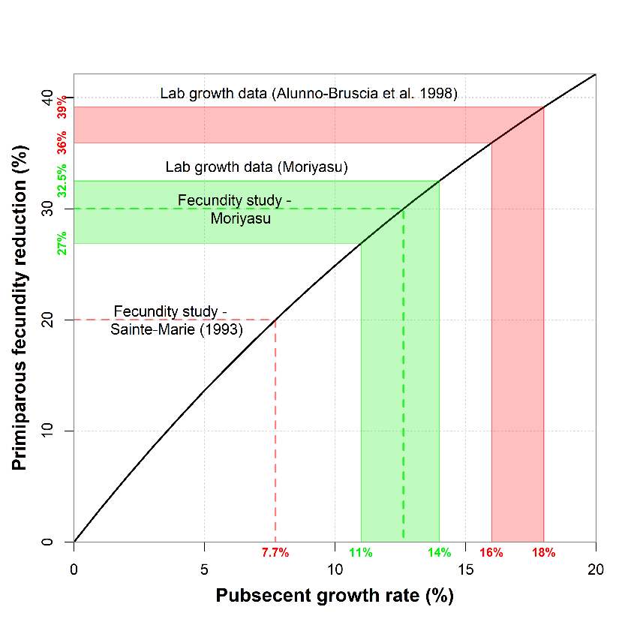
Figure Y : Relation between primiparous and multiparous fecundity difference and pubescent growth rate. The black line shows the theoretical relation, assuming a constant growth rate and an allometric coefficient of 3 in the fecundity-size model (Kon & Adachi 2006 : Primiparous is 33.4% less fecund than multiparous).

Inferring growth rates from two allometric equations with different coefficients:
Let the allometric equation for primiparous and multiparous fecundity be $y=α_{1}x^{β_{1}}$ and $y=α_{2}x^{β_{2}}$, respectively.
Now let’s assume that the crab size $x$ is the result of a crab having grown by some scaling factor $p$. We are making the hypothesis that if the crab size were reverted to its pre-moult size, then the primiparous fecundity would follow the same relation as its multiparous counterparts.
$$α_{2}{\left(\frac{x}{p}\right)}^{β_{2}}=α_{1}x^{β_{1}}$$
$$\frac{1}{p^{β_{2}}}α_{2}x^{β_{2}}=α_{1}x^{β_{1}}$$
$$\frac{1}{p^{β_{2}}}=\frac{α_{1}x^{β_{1}}}{α_{2}x^{β_{2}}}$$
$$\frac{1}{p^{β_{2}}}=\left(\frac{α_{1}}{α_{2}}\right)x^{β_{1}-β_{2}}$$
$$p^{β_{2}}=\left(\frac{α_{2}}{α_{1}}\right)x^{β_{2}-β_{1}}$$
$$p(x)={\left[\left(\frac{α_{2}}{α_{1}}\right)x^{β_{2}-β_{1}}\right]}^{1/β_{2}}$$
Setting ${β_{1}= β}_{2}$ (i.e. on the log-scale, the lines are parallel) yields:
$$p(x)={\left(\frac{α_{2}}{α_{1}}\right)}^{1/β}$$
Substituting using estimated parameter values:
$$p(x)={\left[\left(\frac{0.8085}{0.1748}\right)x^{2.676-2.957}\right]}^{1/2.676}$$
$$p(x)={\left[4.6253 x^{-0.281}\right]}^{1/2.676}$$
$$p(x)=1.7724 x^{-0.105}$$
So we see that the growth proportion also follows an allometric relation. The negative exponent implies that the growth rate is decreasing with size, as is generally assumed (refs). Linear (also called Hiatt) functions are generally used to model crustacean growth increments: $x_{i+1}=ax_{i}+b$. The proportion of growth for this model is given by:
$$p^{'}\left(x\right)=a+\frac{b}{x}$$
We see that this is a reciprocal function that, for positive $b$, is a decreasing function. These two growth models are not equivalent, but can reasonably approximate each other. For example using the Hiatt coefficients from Alunno-Bruscia (1998) ($a=1.071$ and $b=5.099$).
A good linear approximation to the allometric growth model $p(x)=1.7724 x^{-0.105}$ over the interval 40 mm to 80 mm CW is given by the Hiatt model with $a=1.033$ an $b=7.050$. Put in the proportional growth form this is:
$$p^{'}\left(x\right)=1.033+\frac{7.050}{x}$$

Table X : Comparison of fecundity-estimated growth and laboratory growth estimates from laboratory growth data from Alunno-Bruscia (1998).
CW (mm) | Allometric (%) | Alunno-Bruscia (%)
50 | 17.5 | 17.3
51 | 17.3 | 17.1
52 | 17.1 | 16.9
53 | 16.8 | 16.7
54 | 16.6 | 16.5
55 | 16.4 | 16.4
56 | 16.1 | 16.2
57 | 15.9 | 16.0
58 | 15.7 | 15.9
59 | 15.5 | 15.7
60 | 15.3 | 15.6
61 | 15.1 | 15.5
62 | 14.9 | 15.3
63 | 14.7 | 15.2
64 | 14.5 | 15.1
65 | 14.3 | 14.9
66 | 14.2 | 14.8
67 | 14.0 | 14.7
68 | 13.8 | 14.6
69 | 13.6 | 14.5
70 | 13.5 | 14.4

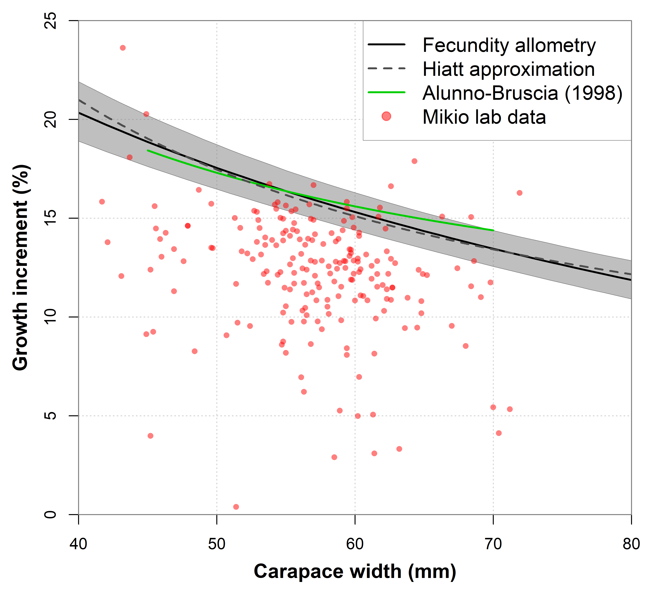
Figure X : Comparison of relative growth rates estimated from the fecundity data (solid and dashed black lines) with those from Alunno-Bruscia (1998) laboratory growth data from Quebec (green line) and Moriyasu’s lab growth data (red circles).

Annex D : Error sources in individual fecundity observations
- Since snow crab carry too many eggs to count directly, individual fecundity must be estimated.
- The method used to estimate individual fecundity may be summarized as follows:
  - The total egg clutch is weighed.
  - A representative sub-sample is extracted and weighed, then the eggs in the sub-sample is counted.
  - Fecundity is calculated as the number of eggs in the sub-sample multiplied by the ratio of total clutch weight and the sub-sample weight.
(D1) $F=n_{s}\frac{w_{t}}{w_{s}}$
- Note that the quantity ${w_{s}}/{n_{s}}$ corresponds to the average egg weight in the sub-sample. Thus, in some studies, some authors estimate fecundity as the total clutch weight divided by the average egg weight in the sub-sample.
- Since the egg clutch weight is usually on the order of a few grams, whereas the weight of the sub-sample is a few milligrams. Because of this, the subsample is usually the limiting factor when calculating individual fecundity.
- The accuracy of the estimate depends on whether the sub-sample has the same composition, i.e. is representative, as that of total egg clutch whose weight was measured. Differences in humidity, cleanliness or condition of the eggs between the sub-sample and the full clutch will lead to bias in the estimated fecundities.

(D2) $F=\frac{w_{t}}{{(w}_{s}/ n_{s})}$

- We see the two methods are mathematically equivalent. Some researchers applied the same egg weight for different females. We’ll see below that this likely leads to error inflation.
- Note that assuming that the average egg weight to be constant, e.g. in a sample batch, will lead to inflated error and/or bias in the fecundity estimates.
Error sources:
- Impact of measurement precision:
  - Weight measurement precision is limited by the precision of the balance, which ranged from 1 mg early in the data series (before 1990) to 0.1 mg in later samples.
  - Total egg clutch weights in dried samples typically range from 1 to 6 g, so balance precision errors are likely negligible, on the order of 0.1% in earlier samples to less than 0.01% in later samples.
  - Dried sub-sample weights typically range from 0.025 mg to 0.035 mg. This implies that the relative error due to weight measurements ranged from 4% earlier in the series to 0.2 - 0.4% in later samples.
  - The number of eggs counted, which was generally 500 or so eggs, also likely has some level of error in it. The counts are off by 5 or 10 eggs, this corresponds to a relative error of about 1% or 2% or so.
  - Taken together, these error sources contribute an error of about 3.5% to fecundity estimates in earlier samples, and about 1% in later samples.
- Impact of estimation error:
  - There is thus an estimation error associated with the fecundity estimates. This estimation error depends on both the intrinsic variability of individual egg weights in the sample, the precision of the weight measurements and the number of eggs in the subsample.
  - Investigations in our lab show that total fecundity on the same female vary by X% when applied to the same female.
- Systematic errors:
  - The accuracy of the individual fecundity estimate depends critically on how well the composition of sub-sample is representative of the total egg clutch. The main factors include the humidity content, or degree of cleanliness (e.g. pleopod or fragments thereof). Deviations between clutch and subsample composition result in biased fecundity estimates.
    - For example, if the sub-sample is cleaner (i.e. contains fewer pleopod fragments) than the egg clutch from which it is extracted, then the fecundity would be overestimated, because the average egg weight in the sample would be less than the average egg weight from the total clutch, which contains “extra” pleopod fragments. Note that the issue isn’t the presence of debris itself, merely that the quantity of debris differs between the subsample and the clutch.
    - One issue that occurs with dried samples if that dried eggs can absorb humidity from the air, so that the time exposed to the air and ambient humidity may be a factor. In this way, eggs in sub-samples may end up weighing slightly more than eggs in the full clutch. This would lead to slight underestimation of fecundity. It is important that the weight of the subsample be taken prior to counting, or that a counted subsample be redried prior to weighing.
  - Treating egg weights as a constant:
    - Some authors (e.g. Davidson et al . (1986) and possibly Sainte-Marie (1993)), when calculating fecundity using average egg weight (Equation D2), made the added assumption that groups of females, say from the same sampling locations or withing the same year, have the same average egg weight.
    - Assuming a constant average egg weight simplifies the lab work required for estimating individual fecundity, requiring only the weight of the total egg clutch as input.
    - However, this likely lead to an important increase of error in the estimates.
    - In our data, individual egg weights varied between 45 and 70 micrograms between different crab. Ignoring this variation would add between 10-40% more variation in the individual fecundity estimates. This was done to speed up operations in that it required only the weighing of the full clutch. For Davidson in particular, the resulting fecundity curves deviate very strongly from the cubic allometry that is the norm, possibly the result of small sample size and ignoring individual egg weight variability.
    - In our dried and prepared samples, individual egg weight had coefficients of variation ranging from 5% to 14%, with an average 7.7%.
  - Estimating fecundity from wet samples:
    - Sainte-Marie (1993) is also unique among studies in that fecundity was estimated from wet rather than dried egg clutches. It is unclear whether samples were taken from each female or whether an aggregate weight was used as in Davidson et al. 1986. In this case, samples were blotted on tissue paper prior to weighing. Wet samples are difficult to clean (separate the pleopods out), and the subsample is likely to be both cleaner and drier than the full clutch, making it likely that the estimated fecundities are overestimates.
    - This might explain why both the primiparous and multiparous curves were much higher than any of our observed samples. Indeed, the multiparous curve is higher than any other curve found in our survey of the literature encompassing 18 studies around the world.
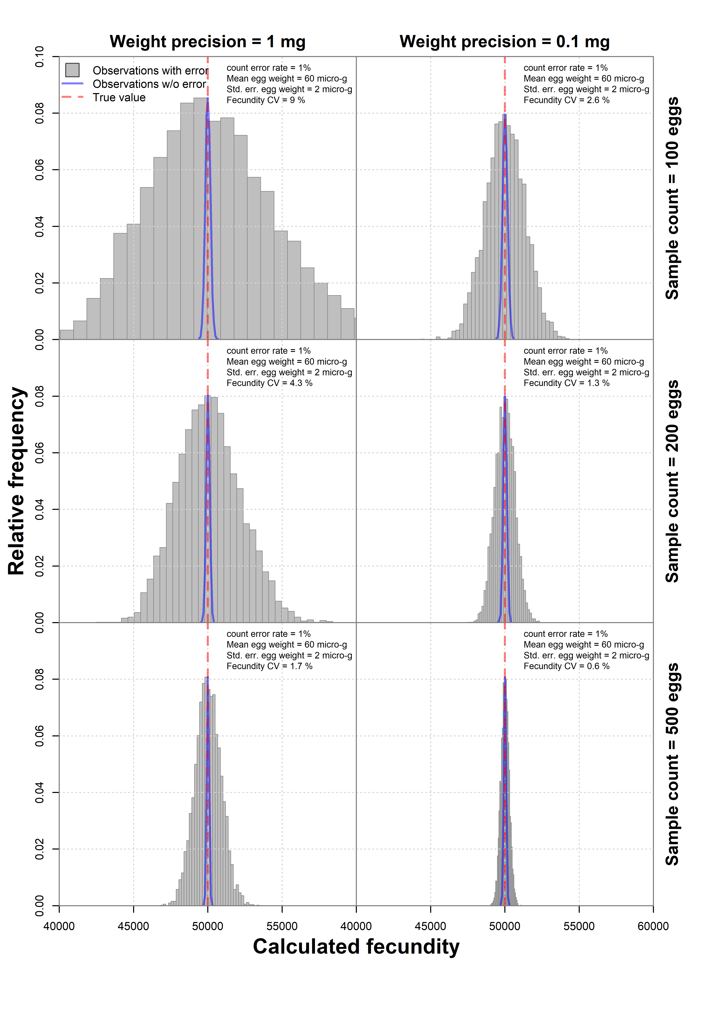
Figure D1 : Simulation results showing the variability in observed fecundity estimates (grey bars) for a clutch of 50,000 eggs whose eggs weigh 60 ± 2 μg, with an egg counting rate of 1%. Columns indicate the precision of the balance scale (1 mg left column and 0.1 mg right column), and rows indicate the number of eggs counted in the sub-sample.
Table X : Summary of error sources when estimating individual fecundity.
Error source: | Contribution | Bias
Measurement precision | 1% to 3.5% | 0%
Estimation error from subsample |  | 0%
Cleaning | Depends | X% to Y%
Humidity | 1% to 3% | -1% to -3%
Treating egg weight as constant | 6% (+/- 15%)
Wet sample | ? | ?

- This means that in older studies, fecundity observations are contaminated by about 5-10% variation from non-systematic errors, such as the precision of the weight balance, count errors and the number of eggs in the sub-sample.
- The main variation is the weight of the dried sub-sample, which ranges from 6mg (n = 100), 12 mg (n = 200) and 30 mg (n = 500). Errors in the milligrams for smaller samples can easily generate errors in the range of 10%.
- Systematic errors can generate further errors by introducing bias.
- How much do dried pleopods weigh? what degree of error can we expect by including them in the clutch weight? Jewett 1981 seems to have done this. I can’t find our data on this subject. This would inflate the fecundity estimate.
- Assuming that egg weight does not vary from female to female, such as taking some average value, adds at least +/- 15% more variability in the observations.

Study | Year | Sub-sample | Weight precision | Maturity | n | Location | Drying | Cleaning method | Issues
Haynes et al. | 1976 | 5% eggs were counted |  | “ All ovigerous C. opilio … were from first-time spawners.” | 23 | SBS | Several days at room temp. | “rubbed to free them of connective tissue” | Unclear if the entire egg clutch was dried, or only the sub-sample.
Jewett | 1981 | 2 x 200 eggs | 1 mg | “new-shelled females” | 63 | South Chukchi Sea | 60°C | “Eggs were dried to a constant weight at 60°C and weighed …”  “eggs were rubbed gently to free them from connective tissue.” | Egg clutch was apparently weighed without cleaning, but the sub-sample was likely cleaned. Also, weight precision is low.
Comeau  et al. | 1999 | 250 eggs was dried for 48 h at 80°C | 0.01 mg (seems high) |  |  |  |  | No cleaning is mentioned. | No apparent cleaning … sub-sample may be cleaner due to extraction from pleopods.
Sainte-Marie | 1993 | 2 x 20 eggs | 0.01 mg |  |  |  |  | “Blotted weight”  No mention of any further cleaning. | Pleopods in the egg mass.  Small samples are likely to contain less humidity than the egg mass.
Burmeister | 2002 | 30 eggs | 0.01 mg |  |  |  |  | No drying, wet clutch weights | Pleopods in the egg mass.  Small samples are likely to contain less humidity than the egg mass.
Kon | 2006 |  |  | Primiparous (98) and young multiparous (25) |  | Wasaka Bay, Sea of Japan |  |  | Can’t read Japanese
Koltz | 2015 | 250-300 eggs |  | Mainly primiparous (49) and 2nd year multiparous (17) | 66 | NBS | 60°C  Min 64h | No mention of cleaning
Divine | 2019 | 250 eggs | Unknown | Unknown | 322 |  | 60 °C | Each total egg clutch was removed from the pleopods, 250 eggs were subsampled and dried at 60 °C to a constant weight, and the dry weight of the subsample was determined  (Stichert, 2009; Webb et al., 2016). The remaining egg mass was also dried as described above to obtain total dry weight. | Fecundity is the lowest

Author(s) | Year | Location | n | Drying | Subsample | Grouping | Comment
Haynes et al. | 1976 | SBS & sGSL | 23 + 99 | room temp | ~5% of clutch | Primiparous
Jewett | 1981 | CS & NBS | 63 + 23 | 60°C | 2 x 200 eggs | Primiparous
Elner & Gass | 1984 | sGSL | 25 + 25 | 70°C | 4 x 30 eggs | Multiparous?
Davidson et al. | 1984 | Nfld | 115 + 98 | 70°C | 4 x 30 eggs | Mixed | Average egg weight of 10 females
Conan et al. | 1989 | sGSL | 698 | 60°C >24h | 500-1000 eggs | Mixed
Sainte-Marie | 1993 | nGSL | 75 + 81 | blotting | 2 x 20 eggs | Spawning stage
Taylor | 1996 | Nfld | 350 | 65°C 24h | 400-700 eggs | Mixed
Paul & Paul | 1997 | Chukchi Sea | 91 | 60°C > 64h | 100 eggs
Comeau et al. | 1999 | West Nfld | 70 | 80°C 48h | 250 eggs | Multiparous
Burmeister | 2002 | Greenland | 75 + 75 | blotting? | 30 eggs | Mixed
Kon & Adachi | 2006 | Sea of Japan | 98 + 25 | ? |  | Spawning stage | C. elongatus
Kolts et al. | 2015 | NBS | 66 | dried | 250-300 eggs | SC (primiparous)
Webb et al. | 2016 | NBS | 853 | 60°C, > 48 h | 2 x 150+ eggs | Shell condition
Danielsen et al. | 2019 | Barents Sea | 185 | 60°C > 24h | 200 egg | Mixed
Divine et al. | 2019 | Chukchi Sea | 322 | 60°C | 250 eggs | Mixed

CS : | Chukchi Sea
sGSL : | Southern Gulf of St. Lawrence
nGSL : | Northern Gulf of St. Lawrence
NFLD : | Newfoundland
SBS : | South Bering Sea
NBS : | North Bering Sea

Annex E : Glossary terms
Spawning stage : Refers to primiparous or multiparous, i.e. the first clutch or the second or more clutch.
Spawning cycle : Refers to whether the females incubate eggs for one year (annual) or two years (biennial).
Incubation year : How long it has been since the eggs have been laid.
Oocyte production : Refers to the number of unfertilized eggs that are produced internally prior to extrusion and fertilization. Processes that affect oocyte production include animal health and energy reserves, as well as metabolic factors which may be influenced by the environment.
Egg loss : Refers to the loss of eggs during incubation. Processes affecting egg loss may include non-fertilized eggs, egg mortality (through parasites or disease), partially hatched eggs, or mechanical loss (through interaction with males for instance).
Reduced fecundity : Refers to females having lower than normal or optimal fecundity levels. This is come combination of lowered oocyte production or egg loss.

To do:
- To check secondary egg loss rates among younger mature females:
  - Primiparous : Compare F between SC1&2 (first year incubation) and SC3 (2nd year incubation)
  - Multiparous : Compare F between SC3 and SC4 (use gonad weights to separate between 1st and 2nd year incubation).
- Show whether SC3 multiparous are more fecund than full-clutched multiparous.
- Check how egg loss rates vary:
  - between the SC4 and SC5 categories.
  - with carapace width (discuss possible triage bias – keeping smaller females with egg loss). Quote existing literature.
- Compare eggs remaining (%) observation with estimated egg loss fraction.
- Provide boxplot or histogram showing the size distribution of samples between regions.
- Remove dropped eggs from data set.
- Remove ‘cage’ samples.
- Make egg loss rates vary by shell condition.
- Check that frozen samples do not look weird wrt other data. Check that egg weights are not different.
- Check primiparous samples with apparent egg loss… check that they are not obvious outliers or shell condition misclassifications.
- Check whether female sizes vary by location. Histogram by location?
Data sampling practices:
- In recent years, target sample sizes in CB and BC were a minimum of 50 (<50 implies no triage) and a maximum of 75 (75 likely implies triage of older females with egg loss).
- Make figure showing:
  - Primiparous and multiparous (with egg loss?) fecundity plot.
  - Overlay your fitted curves and write equations on plot.
  - Overlay other fecundity curves (Kon, Sainte-Marie, Comeau, Haynes, Jewett).
- Estimation variability in fecundity estimates :
  - How error scales with the number of eggs counted.
  - How error varies with subsamples.
  - How air humidity changes the weight over time.
Model results:
- Site x year boxplot:
Time series of Baie des Chaleurs, Bradelle Bank & Cape Breton, with primiparous & multiparous subpanels. One page figure.

